**Sean Poston**

**CS300 Assignment 6**

**4/10/2020**

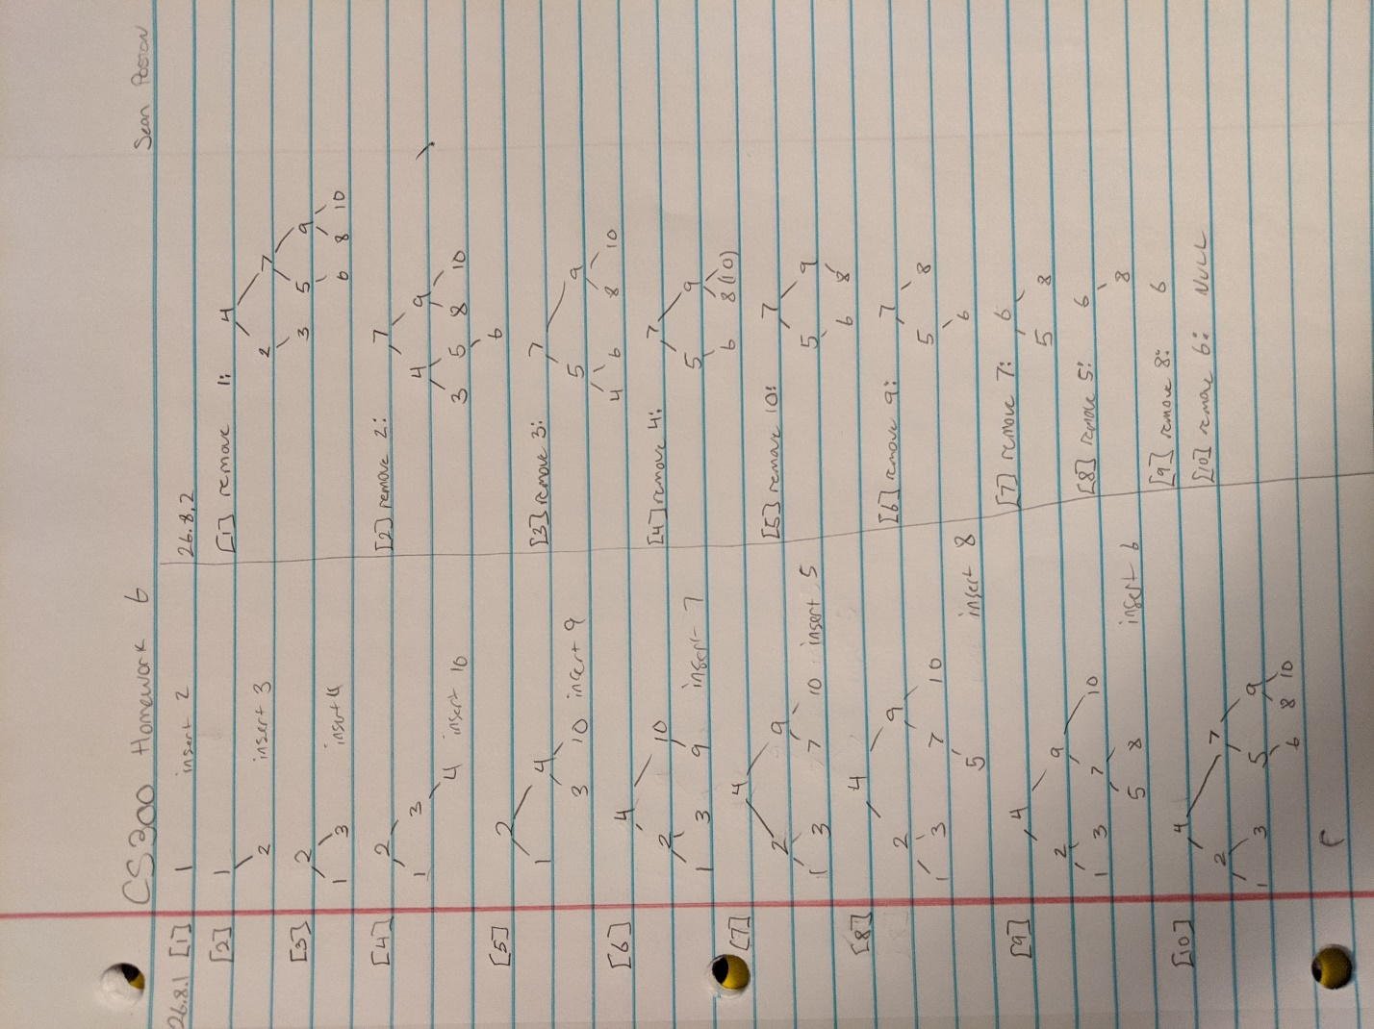

This is the screenshot of my work of balancing an AVL tree. I checked it against a simulator online.